**DAILY ONLINE ACTIVITIES SUMMARY**

|  |  |  |  |  |  |  |  |  |
| --- | --- | --- | --- | --- | --- | --- | --- | --- |
| **Date:** | **19-05-2020** | | | | | **Name:** | **Rohan Mahaveer** | |
| **Sem & Sec** | **6th B** | | | | | **USN:** | **4AL17CS077** | |
| **Online Test Summary** | | | | | | | | |
| **Subject** | | **Computer Graphics and Visualization(CGV)** | | | | | | |
| **Max. Marks** | | **60** | | **Score** | | | **25** | |
| **Certification Course Summary** | | | | | | | | |
| **Course** | **Ethical Hacking** | | | | | | | |
| **Certificate Provider** | | | **Alison** | | **Duration** | | | **6hrs** |
| **Coding Challenges** | | | | | | | | |
| 1. Problem Statement: 1.We have a Letter or a word then we need add some letters to it and need to find out shortest palindrome For example we take "S": S will be the shortest palindrome string. If we take "xyz": zyxyz will be the shortest palindrome string So we need to add some characters to the given string or character and find out what will be the shortest palindrome string by using simple java program. 2. Write a simple code to identify given linked list is palindrome or not by using stack. First take a Stack. Traverse through each node of the linked list and push each node value to Stack. Once the traversal & copying is done, iterate through linked list from head node again. In each iteration, pop one stack element and compare with node value in respective iteration. It is expected to match stack popped value with node value. In case of all matches, its a palindrome. Any one element mismatch makes it not a palindrome. | | | | | | | | |
| Status: YES, Completed all Programs | | | | | | | | |
| **Uploaded the report in Github** | | | | | **YES** | | | |
| **If yes Repository name** | | | | | **Daily-status** | | | |
| **Uploaded the report in slack** | | | | | **YES** | | | |

Online Test Details: (Attach the snapshot and briefly write the report for the same)



Scored 25 out of 60 in CGV 1st I.A test

Certification Course Details: (Attach the snapshot and briefly write the report for the same)

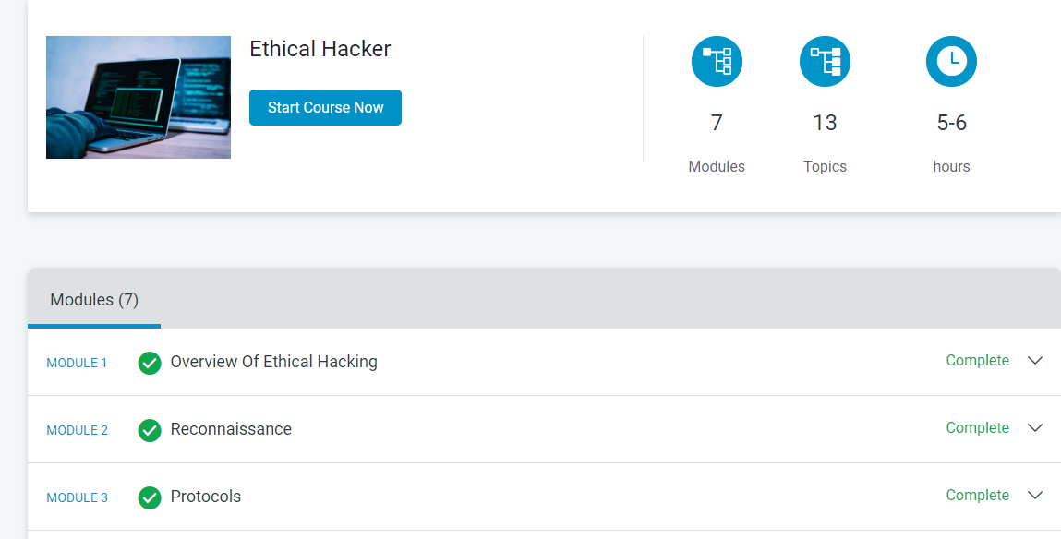

The above course is being taken up by me is based on Ethical hacking. It started with the CIA triad, today in online course I studied about port and protocol relationships, taking a look at what port numbers map to specific protocols. The details of the course and certificate provider are mentioned in the above form.

Coding Challenges Details: (Attach the snapshot and briefly write the report for the same)

